|  |  |
| --- | --- |
| **аcreate** | 2020-09-24T10:26:34+00:00 |
| ApertureValue | 54823/32325 |
| BrightnessValue | -2545/2804 |
| ColorSpace | 65535 |
| ComponentsConfiguration | 1, 2, 3, 0 |
| DateTime | 2020:07:20 19:17:00 |
| DateTimeDigitized | 2020:07:20 19:17:00 |
| DateTimeOriginal | 2020:07:20 19:17:00 |
| ExifImageLength | 3024 |
| ExifImageWidth | 4032 |
| ExifOffset | 230 |
| ExifVersion | 48, 50, 51, 49 |
| ExposureBiasValue | 0/1 |
| ExposureMode | 0 |
| ExposureProgram | 2 |
| ExposureTime | 1/4 |
| Flash | 16 |
| FlashPixVersion | 48, 49, 48, 48 |
| FNumber | 9/5 |
| FocalLength | 399/100 |
| FocalLengthIn35mmFilm | 28 |
| GPSAltitude | 662227/2207 |
| GPSAltitudeRef | 0 |
| GPSDestBearing | 104171/9878 |
| GPSDestBearingRef | T |
| GPSImgDirection | 104171/9878 |
| GPSImgDirectionRef | T |
| GPSInfo | 2056 |
| GPSLatitude | 41/1, 37/1, 2648/100 |
| GPSLatitudeRef | N |
| GPSLongitude | 48/1, 22/1, 2637/100 |
| GPSLongitudeRef | E |
| GPSSpeed | 9387/49681 |
| GPSSpeedRef | K |
| ISOSpeedRatings | 80 |
| Make | Apple |
| MakerNote |  |
| MeteringMode | 5 |
| Model | iPhone 8 |
| Orientation | 6 |
| ResolutionUnit | 2 |
| SceneCaptureType | 0 |
| SceneType | 1 |
| SensingMethod | 2 |
| ShutterSpeedValue | 21191/10292 |
| Software | 13.5.1 |
| SubjectArea | 2015, 1511, 2217, 1330 |
| SubSecTimeDigitized | 850 |
| SubSecTimeOriginal | 850 |
| TileLength | 512 |
| TileWidth | 512 |
| WhiteBalance | 0 |
| XResolution | 72/1 |
| YCbCrPositioning | 1 |
| YResolution | 72/1 |

С помощью утилиты ExifViewer мы узнаем следующие дынные о фотографии:

1. В какое время был скачано фото на компьютер
2. Значение диафрагмы
3. Значение яркости
4. Место где было сделано фото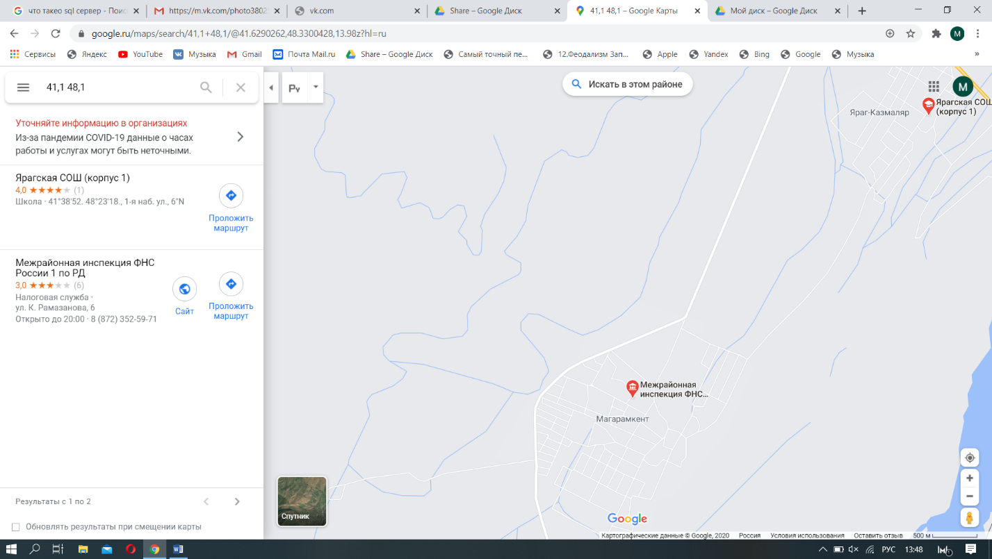

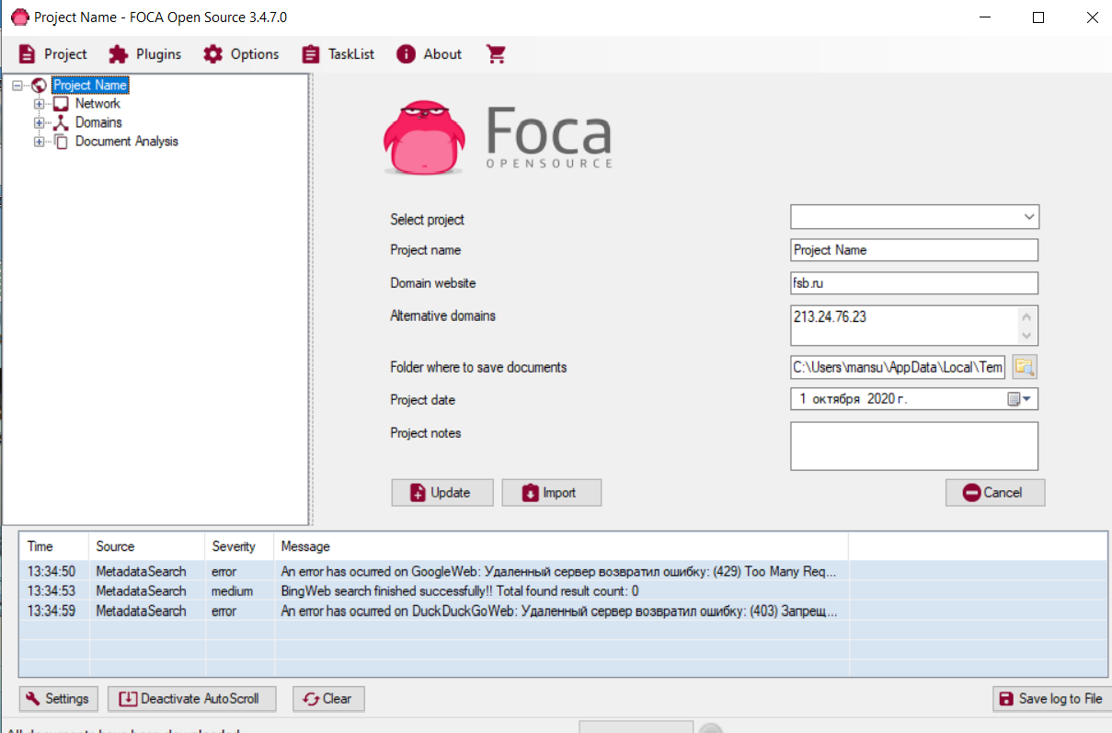

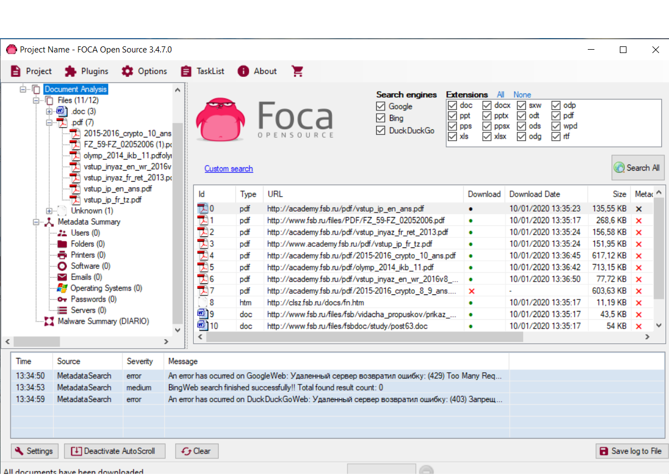

**Ccleaner**

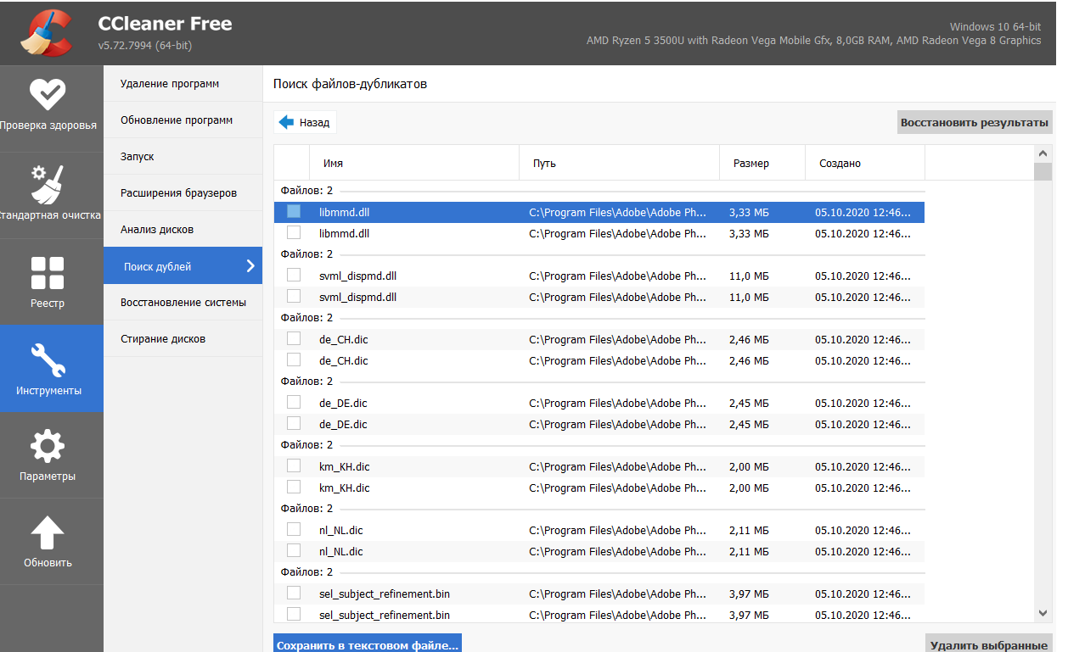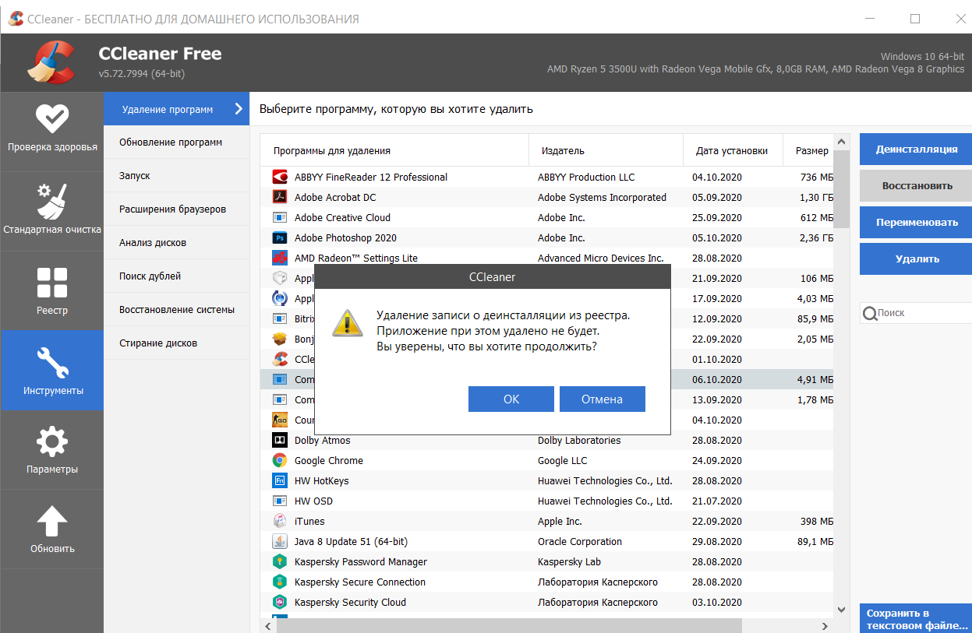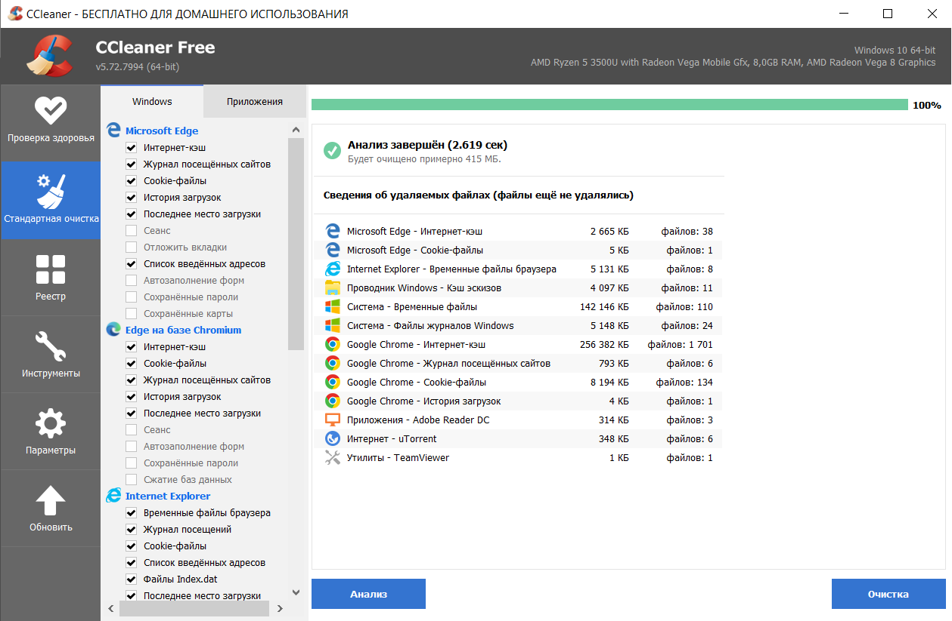

**Rstudio**

